Title: **AQua: An Energy-efficient Water Quality Monitoring and Recording System**

Keywords: Water parameters, Aquaculture, Water, Water Quality, Solar Energy, Arduino, Sensors, Zigbee, ThingSpeak

**BRAINSTORMING**

* **Iot-Based Real-Time River Water Quality Monitoring System**

Current water quality monitoring system is a manual system with a monotonous process and is very time-consuming. This paper proposes a sensor-based water quality monitoring system. The main components of Wireless Sensor Network (WSN) include a microcontroller for processing the system, communication system for inter and intra node communication and several sensors. Real-time data access can be done by using remote monitoring and Internet of Things (IoT) technology. Data collected at the apart site can be displayed in a visual format on a server PC with the help of Spark streaming analysis through Spark MLlib, Deep learning neural network models, Belief Rule Based (BRB) system and is also compared with standard values. If the acquired value is above the threshold value automated warning SMS alert will be sent to the agent. The uniqueness of our proposed paper is to obtain a water monitoring system with high frequency, high mobility, and low power. Therefore, our proposed system will immensely help Bangladeshi populations to become conscious against contaminated water as well as to stop polluting the water.

**Source**: Chowdury, M. S. U., Emran, T. B., Ghosh, S., Pathak, A., Alam, M. M., Absar, N., ... & Hossain, M. S. (2019). IoT based real-time river water quality monitoring system. Procedia Computer Science, 155, 161-168.

* **Arduino-Based Integrated Water Quality Analyzer With Real-Time Data Transmitter**

In our society, there is an accelerated rate of morbidity and mortality worldwide stemming from various water-related diseases. Thus, safety is the most critical factor in decision making for safe-drinking water. Moreover, prompt acquisition of on-the-spot information regarding water quality is still a challenge due to the unavailability of portable devices that can give vital information which hinders the resolution of water-related problems. Another challenge is the transport time of data from one location to another especially from distant or isolated places and the limitation of the locals to interpret the information. In this study, all the problems are solved by the development of a user-friendly portable Arduino-based integrated water quality analyzer which measures the temperature, pH, turbidity, and the total dissolved solids (TDS) of the water which are the core parameters in determining the water quality in just one sitting. Furthermore, the device has a Global System for Mobile Communication (GSM) module which sends real-time data to identified professionals and institutions. To ensure the accuracy of the device, the sensors were subjected to various tests, verifications, and comparisons with standard laboratory equipment. The results show that both the device and the lab equipment had no significant differences, with the data values acquired from the device all falling within ± 5%. The t-test was also done. The p-values for all four parameters are greater than the α value (0.05) which means that the device is indeed accurate with the prototype and laboratory values having no significant difference. The device has great potential in helping people ranging from the locals up to the professionals and institutions by reducing the time of data transport and simplifying the analysis regarding water quality which is crucial in the decision making and action-taking processes of water treatment. The device is expected to be tested in the field as soon as recommendations are well integrated.

**Source**: Alave, E. N. L., Lim, H. A. G., Ronquillo, J. L., & Tugade, M. M. (2020). PORTABLE ARDUINO-BASED INTEGRATED WATER QUALITY ANALYZER WITH REAL-TIME DATA TRANSMITTER

* **A Real Time Low Cost Water Quality Progress Recording System Using Arduino**

There are millions of people who die because of contaminated water. There is a necessity for the development of Water quality monitoring system. This system states whether the water is apparent for drinking. Hence, we propose a monitoring system equipped with a PH sensor, the Turbidity Sensor and water temperature sensor with Arduino Uno as the main board. The physical and chemical properties like pH level, temperature, turbidity, TDS are being monitored using different respective sensors. The values measured by the sensors are being processed by the core controller. The quality of water is monitored continuously and the data is sent to the excel sheet. This system ensures whether the water stored in reservoirs after purification of water is fit for drinking or not. It displays a message on the LCD screen about the portability of water. Our project focuses on providing hygiene drinking water at low cost.

**Source**: Mohiddin, M., Bodapally, K., Siramdas, S., & Sriramula, S. K. (2020). A Real Time Low Cost Water Quality Progress Recording System Using Arduino Uno Board. In Advances in Decision Sciences, Image Processing, Security and Computer Vision (pp. 201-209). Springer, Cham.

* **The State of the World Fisheries and Aquaculture and Sustainability in Action**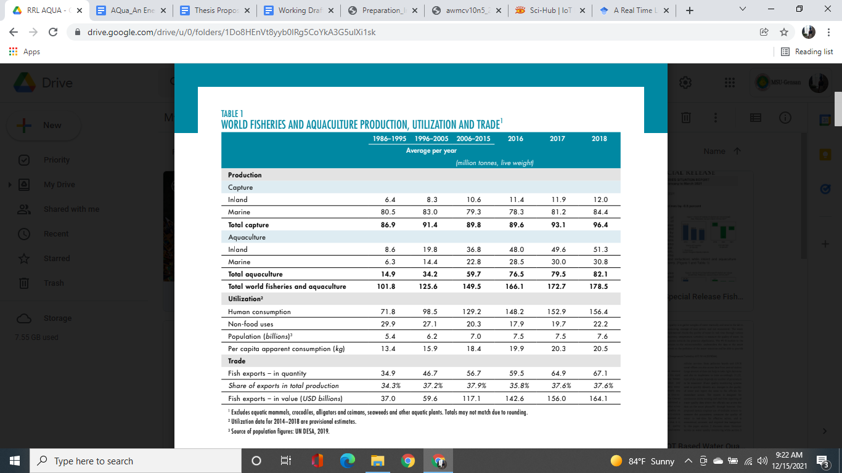

**Source:** Fao. (2020). STATE OF WORLD FISHERIES AND AQUACULTURE 2020 : sustainability in action. Food & Agriculture Org.

* **Fisheries Situation Report, July to September 2021**

Total harvests from aquaculture farms reached 478.42 thousand metric tons from 480.67 thousand metric tons a year ago, which is equivalent to -0.5 percent decline during the quarter. Aquaculture sub sector constituted the biggest share of 48.1 percent of total fisheries production. During the third quarter of 2021, total fisheries production of 995.47 thousand metric tons went down by -2.1 percent from the 1,016.46 thousand metric tons output a year ago. Decreases in production were noted in commercial, marine municipal fisheries, and aquaculture.

**Source:** Fisheries Situation Report, July to September 2021 | Philippine Statistics Authority. (n.d.). Psa.gov.ph. Retrieved December 15, 2021, from https://psa.gov.ph/content/fisheries-situation-report-july-september-2021-0

* ‌**Special Release Fisheries**

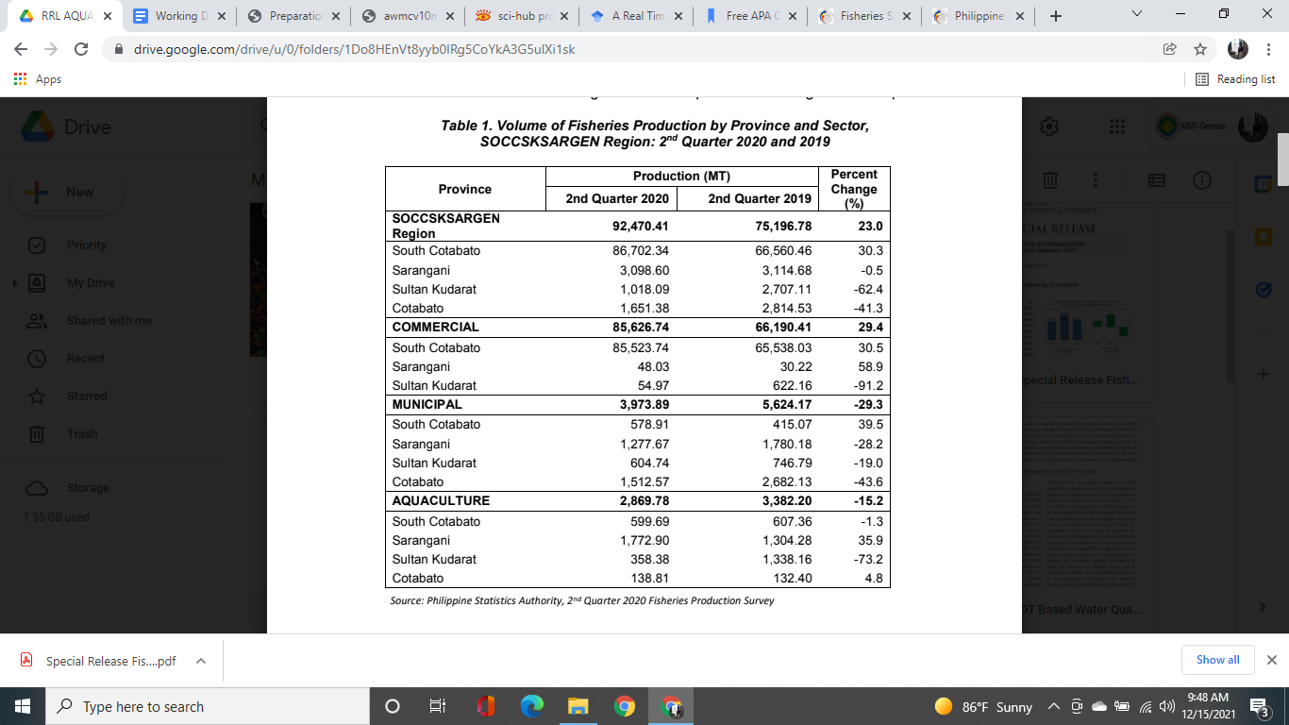

Fisheries production in SOCCSKSARGEN Region reached 92,470 metric tons in the 2nd quarter of 2020, up by 23.0% from the same period in 2019. Among the four (4) provinces in the region, only South Cotabato has posted an increase in production when compared to the same period last year. At 86,702 metric tons, South Cotabato accounted for 93.8% of the total regional fisheries production during the review period.

**Source:** *SOCCSKSARGEN REGION’s 2nd QUARTER 2020 FISHERIES PRODUCTION UP BY 23.0 PERCENT | Philippine Statistics Authority SOCCSKSARGEN Region*. (2020). Psa.gov.ph.http://rsso12.psa.gov.ph/article/soccsksargen-region%E2%80%99s-2nd-quarter-2020-fisheries-production-230-percent

* **‌Smart Water Quality Monitoring System**

Nowadays Internet of Things (IoT) and Remote Sensing (RS) techniques are used in different areas of research for monitoring, collecting and analyzing data from remote locations. Due to the vast increase in global industrial output, rural to urban drift and the over-utilization of land and sea resources, the quality of water available to people has deteriorated greatly. The high use of fertilizers in farms and also other chemicals in sectors such as mining and construction have contributed immensely to the overall reduction of water quality globally. Water is an essential need for human survival and therefore there must be mechanisms put in place to vigorously test the quality of water that is made available for drinking in town and city articulated supplies as well as the rivers, creeks and shoreline that surround our towns and cities. The availability of good quality water is paramount in preventing outbreaks of water-borne diseases as well as improving the quality of life. Fiji Islands are located in the vast Pacific Ocean which requires a frequent data collecting network for the water quality monitoring and IoT and RS can improve the existing measurement.

**Source:** Prasad, A. N., Mamun, K. A., Islam, F. R., & Haqva, H. (2015, December). Smart water quality monitoring system. In *2015 2nd Asia-Pacific World Congress on Computer Science and Engineering (APWC on CSE)* (pp. 1-6). IEEE.

# **Water Quality Monitoring with Arduino Based Sensors**

Water is a quintessential element for the survival of mankind. Its variety of uses means that it is always in a constant state of demand. The supply of water most primarily comes from large reservoirs of water such as lakes, streams, and the ocean itself. As such, it is good practice to monitor its quality to ensure it is fit for human consumption. Current water quality monitoring is often carried out in traditional labs but is time consuming and prone to inaccuracies. Therefore, this paper aims to investigate the feasibility of implementing an Arduino-based sensor system for water quality monitoring. A simple prototype consisting of a microcontroller and multiple attached sensors was employed to conduct weekly onsite tests at multiple daily intervals. It was found that the system works reliably but is reliant on human assistance and prone to data inaccuracies. The system however, provides a solid foundation for future expansion works of the same category to elevate the system to being Internet of Things (IoT) friendly.

**Source:** Hong, W. J., Shamsuddin, N., Abas, E., Apong, R. A., Masri, Z., Suhaimi, H., Gödeke, S. H., & Noh, M. N. A. (2021). Water Quality Monitoring with Arduino Based Sensors. *Environments*, *8*(1), 6. <https://doi.org/10.3390/environments8010006>

* **‌IOT Based Water Quality Monitoring System**

The conventional method of testing water quality is to gather samples of water manually and send them to the lab to test and analyze. This method is time consuming, wastage of manpower, and not economical. The water quality measuring system that we have implemented checks the quality of water in real time through various sensors (one for each parameter: pH, conductivity, temperature, turbidity) to measure the quality of water. As a variation in the value of this parameter points towards the presence of pollutants. The Wi-fi module in the system transfers data collected by the sensors to the microcontroller, and transfers the data to the smartphone/PC. This system can keep a strict check on the pollution of the water resources and be able to provide an environment for safe drinking water.

**Source:** Shirode, M., Adaling, M., Biradar, J., & Mate, T. (2018). IOT based water quality monitoring system. *International Journal of Scientific Research in Computer Science, Engineering and Information Technology*, *3*(1), 1423-1428.

* **An Assessment of Aquaculture Production and Water Monitoring Practices in Selected Province in Mindanao, Philippines**

Aquaculture is the fastest growing form of food production in the world. It is also a significant source of protein for people in many countries. Globally, nearly half the fish consumed by humans is produced by fish farms. Aquaculture contributes significantly to the country's food security, employment and foreign exchange earnings. In the Philippines, aquaculture is very popular at the farm level. Occupying in the production of aquaculture products like milkfish, tilapia, seaweeds, oyster, mollusk, mussel and shrimps provides increased rural employment, livelihood and food security hence, improving the productivity of aquaculture industry. However, there are several issues and concerns confronting the aqua farmer that affect their productivity. In this study, an assessment was conducted on the existing practices of aqua farmers in the water monitoring system in selected provinces in Mindanao. Results of this assessment study are valuable inputs in coming up with an innovative real-time water quality monitoring device to improve yield production and mitigate fish kill in the aquaculture industry.

**Source:** Dr. Consorcio S. Namoco, Maricel F. Gamolo-Dayaday, 2014, An Assessment of Aquaculture Production and Water Monitoring Practices in Selected Provinces in Mindanao, Philippines, INTERNATIONAL JOURNAL OF ENGINEERING RESEARCH & TECHNOLOGY (IJERT) Volume 03, Issue 12 (December 2014)

* **Knowledge Based Real Time Monitoring System for Aquaculture Using IoT**

The Internet of things is one of the rapidly growing fields for delivering social and economic benefits for emerging and developing economies. The field of IOT is expanding its wings in all the domains like medical, industrial, transportation, education, mining etc. Now-a-days with the advancement in integrated on chip computers like Arduino, Raspberry pi the technology is reaching the ground level with its application in agriculture and aquaculture. Water quality is a critical factor while culturing aquatic organisms. It mainly depends on several parameters like dissolved oxygen, ammonia, pH, temperature, salt, nitrates, carbonates etc. The quality of water is monitored continuously with the help of sensors to ensure growth and survival of aquatic life. The sensed data is transferred to the aqua farmer mobile through the cloud. As a result preventive measures can be taken in time to minimize the losses and increase productivity

**Source:** K. R. S. R. Raju and G. H. K. Varma, "Knowledge Based Real Time Monitoring System for Aquaculture Using IoT," 2017 IEEE 7th International Advance Computing Conference (IACC), 2017, pp. 318-321, doi: 10.1109/IACC.2017.0075.

* **IoT Based Automated Fish Farm Aquaculture Monitoring System**

Internet of Things (IoT) is a very fast growing technology and the field of IoT is extending its wings in every one of the areas today. With the progression in computers like Arduino, Raspberry pi, the innovation is achieving the ground level with its application in farming and aquaculture. In this work, we have outlined and actualized monitoring of water quality of aquaculture utilizing Raspberry Pi, Arduino, various Sensors, Smartphone Camera and Android application. Water quality parameters used in this work are Temperature, pH, Electrical Conductivity and Colour. Sensor acquisition is conducted by Arduino and Raspberry Pi is used as a data processing device as well as server. Photo acquisition is also performed by Raspberry Pi with the help of the smartphone camera to detect the colour of the water. Android phones are used as the terminal device. A user can monitor the water condition using an android app through Wi-Fi with Wi-Fi range and through Internet from anywhere in the world. Some analysis is performed with the four parameters value to determine the overall approximate condition of the water and required action. Every feature in this checking gadget can work legitimately and easily.

**Source:** Saha, S., Rajib, R. H., & Kabir, S. (2018, October). IoT based automated fish farm aquaculture monitoring system. In *2018 International Conference on Innovations in Science, Engineering and Technology (ICISET)* (pp. 201-206). IEEE.

* **Design of Online Data Measurement and Automatic Sampling System for Continuous Water Quality Monitoring**

In this research, it has been designed a continuous water quality monitoring system consisting of sensors for measuring Dissolved Oxygen (DO) and pH, data acquisition based on a PCDuino microcontroller, a sample collection unit, and PC based graphical display. The main part of the system is the PCDuino microcontroller, which has a function of controlling the data transmission and the operation of the automatic sampling unit based on comparison of the measured parameter values against a certain threshold. The automatic sampling unit was constructed from PVC holder, a 12V motor stepper, a 12V DC pump, and 8 glass tube sample storages. Experimental results showed that when the measured DO value dropped below 5 mg/l, or the pH values below 4 or above 9, the sample collection unit worked by filling up a 20 ml sample in just under 650 ms. All the measured data can be displayed on a PC for further analysis. This prototype system is expected to find wide applications in the field of environmental and aquaculture monitoring.

**Source:** Wiranto, G., Mambu, G. A., Hermida, I. D. P., & Widodo, S. (2015, August). Design of online data measurement and automatic sampling system for continuous water quality monitoring. In *2015 IEEE International Conference on Mechatronics and Automation (ICMA)* (pp. 2331-2335). IEEE.

* **A LPWAN based Wireless Sensor Node for Aquaculture Water Quality Monitoring System**

The monitoring of water quality becomes a necessity in the aquaculture system to ensure the growth and vitality of the fish. There exists several influencing factors to the water quality including acidity (pH), turbidity, dissolved oxygen and temperature level. As an alternative, the role of farmers could be replaced with a wireless sensor network (WSN) system with the aim of achieving efficiency, accuracy, and remote access. This study proposed the design of wireless sensor nodes to monitor water conditions. The LoRa module was used as communication protocol between node sensor and the gateway due to its efficient power consumption along with wide transmission range which is very appropriate to be applied in aquaculture systems that are usually far away or have limited electricity resources. Based on the sensor node functionality testing, the sensor node could respond to the environmental changes appropriately. In the performance testing result the best delay was 189,4 ms which was found on 40m communication range and 82byte of data. The increasing value of communication range also caused linearly increase of the packet loss.

**Source:** Bhawiyuga, A., & Yahya, W. (2018, November). MA LPWAN based Wireless Sensor Node for Aquaculture Water Quality Monitoring System. In *2018 International Conference on Sustainable Information Engineering and Technology (SIET)* (pp. 252-256). IEEE.

* **IoT and WSN Based Water Quality Monitoring System**

SmartCity projects growing with the concept of IoT (Internet of Things) and WSN (Wireless Sensor Network) helps to manage assets and resources efficiently. Nowadays water is getting polluted due to industrialization, use of fertilizers and pesticides, urban development, etc. So we should have a reliable water quality monitoring system. The proposed system based on IoT and WSN gives real-time data of water quality so that the authority can manage and conserve the valuable water resources more effectively. With IoT & WSN, smart monitoring and management is attainable. It helps create more efficient city services and to keep citizens informed. The existing systems of water quality monitoring uses wireless technologies which are short range and much power consuming, which are not suited for sensor nodes in WSN. The proposed system presents a low cost, low power, long range and scalable approach for water quality monitoring using LoRa module based on LoRaWAN protocol which is Low-Power Wide Area Network (LPWAN) technology, which is much more efficient than many existing systems. The design of the proposed system includes integrating sensors to the microcontroller, wireless LoRa module for transmitting and receiving sensor values, and the ThingSpeak IoT platform for examining and visualizing water quality sensor values which have been uploaded. Water quality sensors include pH, turbidity, temperature, and also perform calculations of the dissolved oxygen content of the water. The gateway here is the ESP32 Wi-Fi module. The gateway then transmits the sensor data packets to the ThingSpeak cloud server over internet protocol and we can monitor the sensor values in ThingSpeak API, in internet enabled devices.

**Source:** Simitha, K. M., & Raj, S. (2019, June). IoT and WSN based water quality monitoring system. In 2019 3rd International conference on Electronics, Communication and Aerospace Technology (ICECA) (pp. 205-210). IEEE.

* **ThingSpeak Server**

ThingSpeak is an IoT data collection application for analysis of various sensors, e.g. pH, turbidity, voltage, temperature, moisture, distance, etc. The data collector collects data from edge node devices (this happens with the NodeMCU/ESP8266) and also allows the data to be modified for historical data analysis in a software environment. First, the user must log in with details on his/her server. The channel containing data fields and a status field is the primary component of ThingSpeak activity. After a ThingSpeak channel has been developed, data is modified, processed, and interpreted with MATLAB code, and the data is reacted to by tweets and other alerts.

**Source:** Das, B., & Jain, P. C. (2017, July). Real-time water quality monitoring system using Internet of Things. In 2017 International conference on computer, communications and electronics (Comptelix) (pp. 78-82). IEEE.

* **Water monitoring and analytic based ThingSpeak**

Diseases associated with bad water have largely been reported annually leading to deaths, therefore the water quality monitoring has become necessary to provide safe water. Traditional monitoring includes manual gathering of samples from different points on the distributed site, and then testing in the laboratory. This procedure has proven that it is ineffective because it is laborious, lag time and lacks online results to enhance proactive response to water pollution. Emergence of the Internet of Things (IoT) and step towards smart life poses the successful use of IoT. This paper presents a water quality monitoring using IoT based ThingSpeak platform that provides analytic tools and visualization using MATLAB programming. The proposed model is used to test water samples using sensor fusion techniques such as TDS and Turbidity, and then uploading data online to the ThingSpeak platform to monitor and analyze. The system notifies authorities when there are water quality parameters out of a predefined set of normal values. A warning will be notified to the user by IFTTT protocol.

**Source:** Miry, A. H., & Aramice, G. A. (2020). Water monitoring and analytic based ThingSpeak. International Journal of Electrical and Computer Engineering, 10(4), 3588.

* **Wireless Sensor Network Applications: A Study in Environment Monitoring System**

Development in the technology of sensors such as Micro Electro Mechanical Systems (MEMS), wireless communications, embedded systems, distributed processing and wireless sensor applications have contributed a large transformation in Wireless Sensor Network (WSN) recently. It assists and improves work performance both in the field of industry and our daily life. Wireless Sensor Network has been widely used in many areas especially for surveillance and monitoring in agriculture and habitat monitoring. Environment monitoring has become an important field of control and protection, providing real-time system and control communication with the physical world. An intelligent and smart Wireless Sensor Network system can gather and process a large amount of data from the beginning of the monitoring and manage air quality, the conditions of traffic, to weather situations. In this paper, we discuss and review wireless sensor network applications for environmental monitoring. In order to implement a good monitoring system, there are several requirements to be followed. From the studies, it has been proved to be an alternative way to replace the conventional method that uses men's force to monitor the environment. It is also proven that these approaches can improve the system performance, provide a convenient and efficient method and can also fulfill functional requirements.

**Source:** Othman, M. F., & Shazali, K. (2012). Wireless sensor network applications: A study in environment monitoring system. Procedia Engineering, 41, 1204-1210.

* **Wireless Sensor Network**

Recent technologies in wireless communications and electronics have brought the vision of Wireless Sensor Network (WSN) into reality which have increased the growth of low cost, low power and multi-functional sensors that are small in size and can communicate in short range. Each node consists of microcontrollers, memory and transceiver. The microcontrollers are used to execute tasks, data processing and assist the functionality of other components in the sensor node. For the memory, it is mainly used for data storage while the transceiver acts from the combination of transmitter and receiver functions. Natural phenomena data such as temperature, light, sound and pressure are collected by sensors and then transmitted to a server. These battery powered nodes are used to monitor and control the physical environment from remote locations. In the past few years, the applications of Wireless Sensor Network have been widely used and applied in medical, military, industrial, agricultural and environmental monitoring.

**Source:** Mohd. Ezwan Jalil. (2011). Positioning and Location Tracking Using Wireless Sensor Network (Doctoral dissertation, Universiti Teknologi Malaysia).

* **Energy Efficient Solutions in Wireless Sensor System for Monitoring the Quality of Water: A Review**

However, the WQN contained in WSN-WQM applications have several resource constraints that range from communication capabilities, limited energy, processing capabilities, to limited memory for data storage. Among the aforementioned constraints in resources, energy is the most crucial resource of all. The main reason for its high significance is that all components of a sensor node depend on it, as it is used for powering sensors. Energy limitation has been a longstanding issue in WSN applications, while seeking solutions to the problem has been an active area of research in recent years. Typically, when there is a lack of energy in a network, one can say that there is an energy crisis in such a network, which is technically referred to as energy scarcity. This is an indication that energy resources are a scarce commodity among the energy hungry WQN in WSNs. The energy scarcity problem in WSNs is a major issue that hinders the development and the continuous popularity of WSN applications.

**Source:** Olatinwo, S. O., & Joubert, T. H. (2018). Energy efficient solutions in wireless sensor systems for water quality monitoring: A review. IEEE Sensors Journal, 19(5), 1596-1625.

* **Energy Harvesting System**

Energy harvesting is concerned with the scavenging of energy from renewable energy sources. These types of energy are naturally occurring energy in the environment, and they are therefore freely available. Energy from these sources is green and likewise gives birth to green communication in wireless networks. To exploit the numerous benefits of renewable energy sources, energy harvesting systems are employed. It is worth clarifying that some energy harvesters operate as an AC source, while others are modelled as a DC source. An energy harvesting system can be described as an embedded system in WSNs, employed to address energy problems such as energy scarcity. It is composed of three basic components, namely an energy harvester, energy storage, and an energy management unit [84]. The energy harvester is employed to harvest energy from energy harvesting sources, and converts it into an electrical energy suitable for powering the sensor node components (sensing unit, processing unit, transceiver unit). Thereafter, the generated electrical energy is delivered to the energy management unit for further action.

Energy harvesting sources can be classified into three basic categories, namely, radiation energy sources (RF waves, solar), mechanical energy sources (vibrations, wind, water flow, blood flow), and thermal energy sources (external heat, body heat). Examples of EH techniques are solar EH, thermal EH, vibration EH, and radio frequency (RF) EH.

**Source:** Olatinwo, S. O., & Joubert, T. H. (2018). Energy efficient solutions in wireless sensor systems for water quality monitoring: A review. IEEE Sensors Journal, 19(5), 1596-1625.

* **Solar energy harvesting**

Energy can be harvested from light produced by artificial means or by natural means. An example of an artificial light source is a man-made light, such as a torch, while an example of natural light is sunlight (solar). Using a photovoltaic method, the light obtained from the identified sources can be converted into electrical energy. Solar energy harvesting solution models have been developed. Different harvesting systems have been developed to harvest energy for light environments, either indoor or outdoor. This technique may be applied to WSNs devoted to the monitoring of WQ, to enhance the system viability. The efficiency of this method depends on the efficiency of the photovoltaic (or solar) cell type employed. Some examples of photovoltaic cells are thin film, mono-crystalline, and poly-silicon. Note that the mono-crystalline type is commonly employed because of its high energy conversion efficiency which is typically less than 25%. Consequently, it is key to underline that this method has a low efficiency. Furthermore, this method is limited when light is not available and also suffers from quick depletion. Solar EH may support both AC and DC sources depending on the source of light. As an example, in the case of sunlight, an AC source is applicable, while a DC source is employed in the case of an artificial indoor light that is based on rechargeable cells.

**Source:** Olatinwo, S. O., & Joubert, T. H. (2018). Energy efficient solutions in wireless sensor systems for water quality monitoring: A review. IEEE Sensors Journal, 19(5), 1596-1625.

* **Solar Powered Water Quality Monitoring system using wireless Sensor Network**

The idea of ‘Underwater Wireless Sensor Network (UWSN) is the basic building block of water quality monitoring using wireless sensor network (WSN) technology powered by solar panels. To monitor water quality over different sites as a real-time application, an excellent system architecture constituted by distributed sensor nodes and a base station is suggested. The nodes and base station are connected using WSN technology like Zigbee. Design and implementation of a prototype model using one node powered by solar cell and WSN technology is challenging work. Data collected by various sensors at the node side such as pH, turbidity and oxygen level is sent via WSN to the base station. Data collected from the remote site can be displayed in visual format as well as it can be analyzed using different simulation tools at the base station. This novel system has advantages such as no carbon emission, low power consumption, more flexibility to deploy at remote sites and so on.

**Source:** Amruta, M. K., & Satish, M. T. (2013, March). Solar powered water quality monitoring system using wireless sensor network. In 2013 International Mutli-Conference on Automation, Computing, Communication, Control and Compressed Sensing (iMac4s) (pp. 281-285). IEEE.

* **Zigbee Module Arduino**

A wireless technology like Zigbee works on standard IEEE 802.15.4 protocol & operates on unlicensed bands worldwide at the frequencies 2.400-2.484GHz, 902-928MHz and 868.0-868.6MHz. Low cost, low power (3.3V), and up to 65000 nodes with an AES encryption standard for communication are the main advantages of Zigbee.

**Source:** Jiang, P., Huang, Q., Wang, J., Dai, X., & Lin, R. (2006, August). Research on wireless sensor networks routing protocol for wetland water environment monitoring. In First International Conference on Innovative Computing, Information and Control-Volume I (ICICIC'06) (Vol. 3, pp. 251-254). IEEE.

ZigBee keyword is a kind of standard protocol that combines the physical Radio Frequency (RF) layer, complies with IEEE 802.15.4 physical radio specification and operates in unlicensed bands commonly 2.4 GHz, 900 MHz and 868 MHz spectrum [4,8]. This project used the 2.4 Ghz ISM spectrum band for all nodes except the GSM modem network. The further description on ZigBee then is to define the protocol created by Zigbee Alliance which are featured as:

• Low Duty Cycle- to enhance long battery life

• Support for multiple network topologies such as point-to-point, point-to-multipoint and mesh networks

• Low latency-suitable for real-time observation

• Direct Sequence Spread Spectrum (DSSS)

• Up to 65,000 nodes per network

• 128-bit AES encryption for secure data connections

• Collision avoidance, retries and acknowledgements

The core ZigBee specification defines ZigBee's smart, cost effective and energy-efficient mesh network. It's an innovative, self-configuring, self-healing system of redundant, low-cost, very low-power nodes that enable ZigBee's unique flexibility, mobility and ease of use. An energy saving coverage will also conclude in WSN futures as it has a small size and battery life dependence which is limited to get powered. Hence, the ‘active’ and ‘hibernation’ nodes will help to conserve the power source.

**Source:** Nasirudin, M. A., Za'bah, U. N., & Sidek, O. (2011, September). Fresh water real-time monitoring system based on wireless sensor network and GSM. In 2011 IEEE Conference on Open Systems (pp. 354-357). IEEE.